**Appendix F**

**Title**: Sprint Boards & Backlogs

**Relevance**: The team relied on the Trello online portal for managing and designing tasks and cards to do and assigning team members to them. A board for each sprint was used to prevent cluttering and lists were used for product backlogs, sprint backlogs and sections for tasks on hold, ready to be started, currently in progress and done.

**Sprint 1**

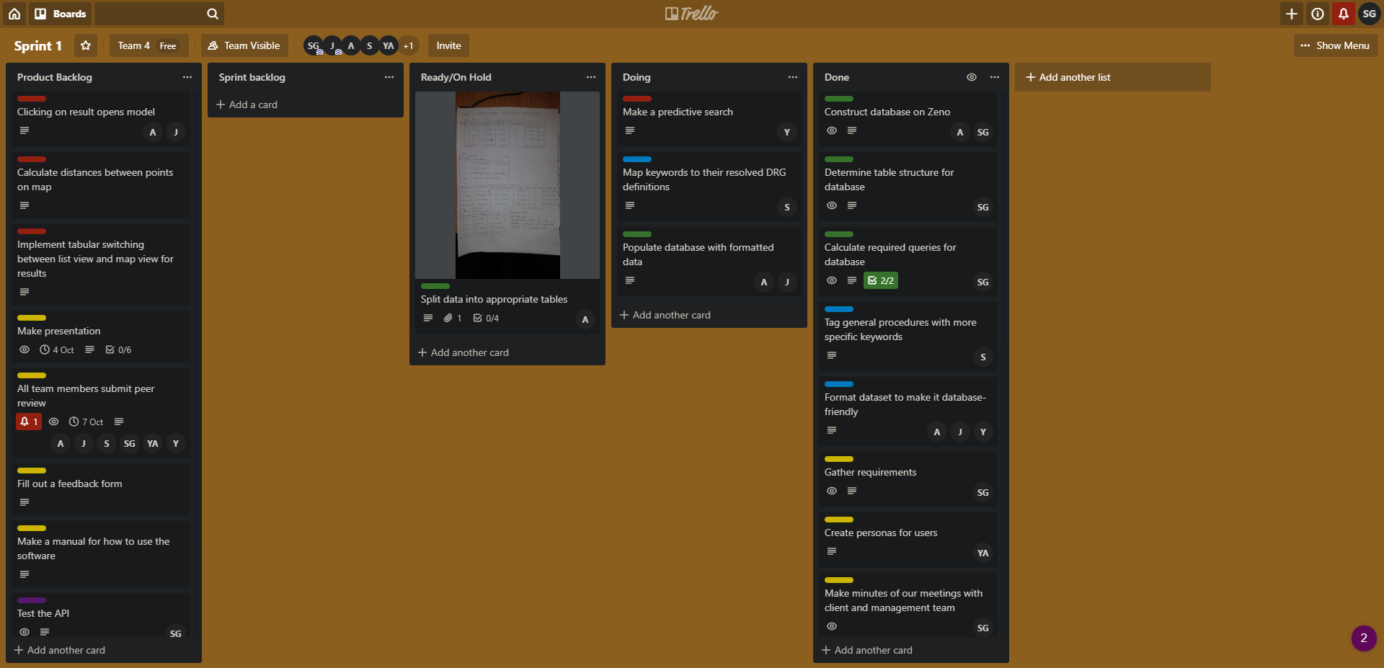

**Sprint 2**

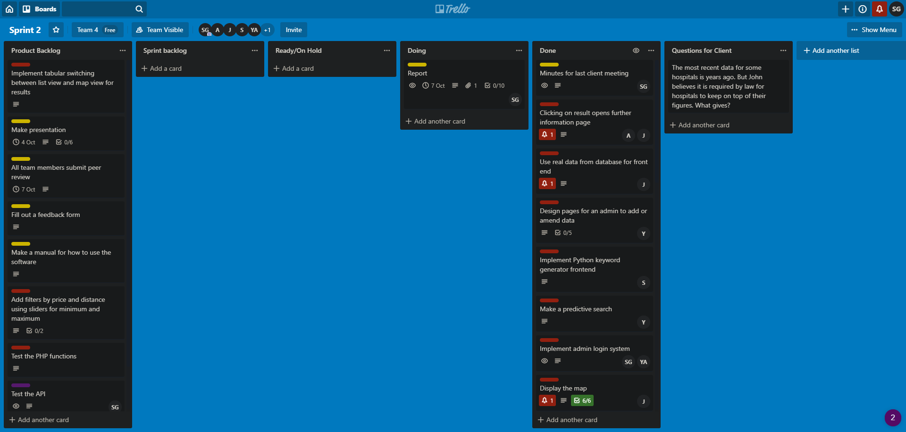

**Sprint 3**

